TEST RESULT
- PQ-TC-01: Monthly Data Load Throughput (Performance)
Objective:
To ensure the application handles production-level volumes (150+ files, >50MB) without failure or performance degradation.
Procedure:
- System Launch: Launch `AirQualityReview.exe`.
- Directory Selection: Select the folder containing 150 CSV files.
- Baseline Monitoring: Record initial Memory usage in Task Manager.
- Analysis Execution: Start a stopwatch and click 'Analyze'.
- Continuous Monitoring: Note any "Not Responding" events or CPU spikes > 90% for more than 10 seconds.
- Completion: Stop stopwatch upon completion and record final Memory usage.
Acceptance Criteria:
- Analysis completes in under 5.0 minutes.
- Memory usage increase (Post-analysis minus Baseline) is less than 200MB.
- The system remains stable with no fatal hangs.
- Evidence: Screenshots of Task Manager (Before/After) and Stopwatch.
Results: The program is highly resource-efficient; it processed 233 CSV files in under 10 seconds with minimal CPU and RAM usage based on testing computer specification as figure below.

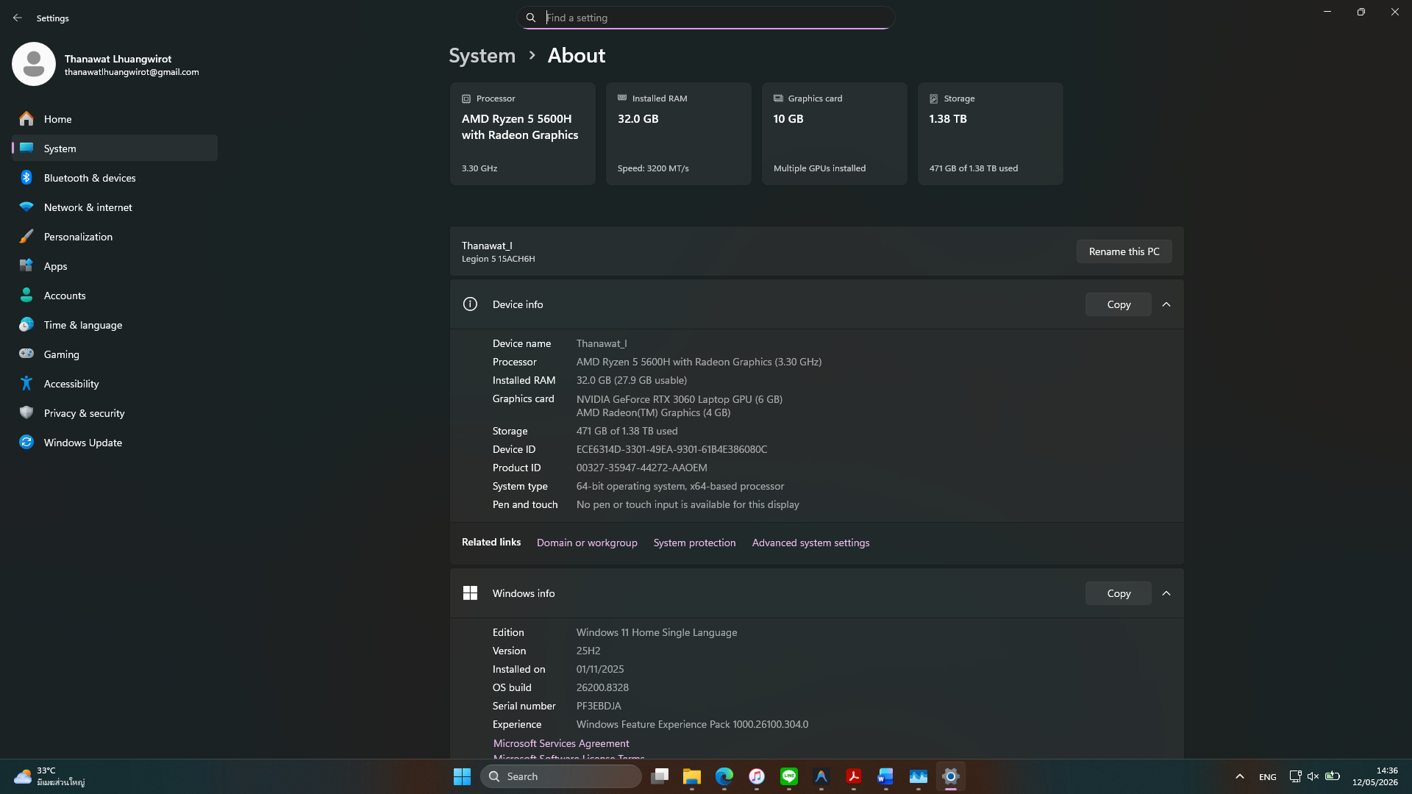
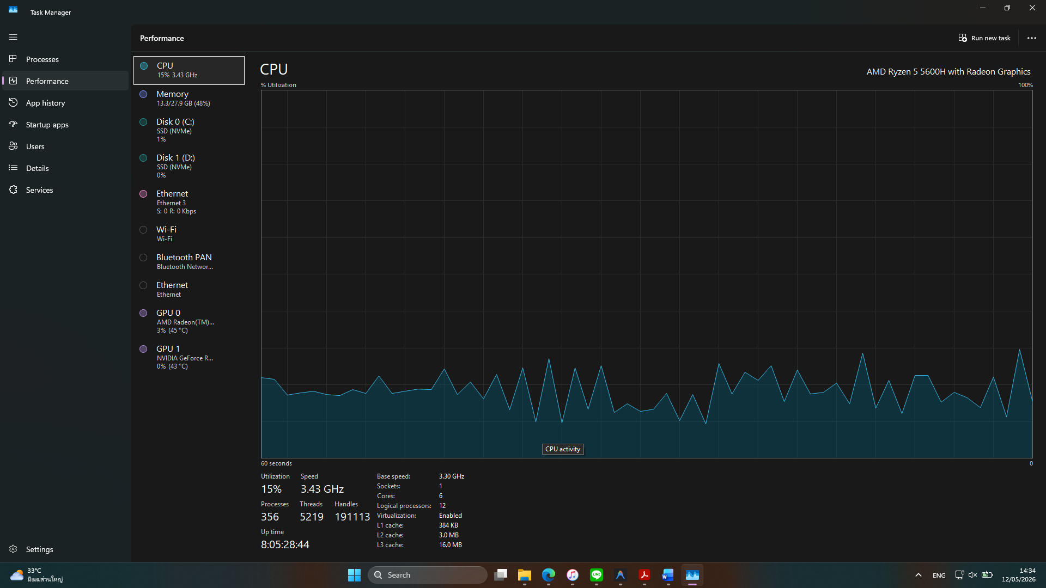
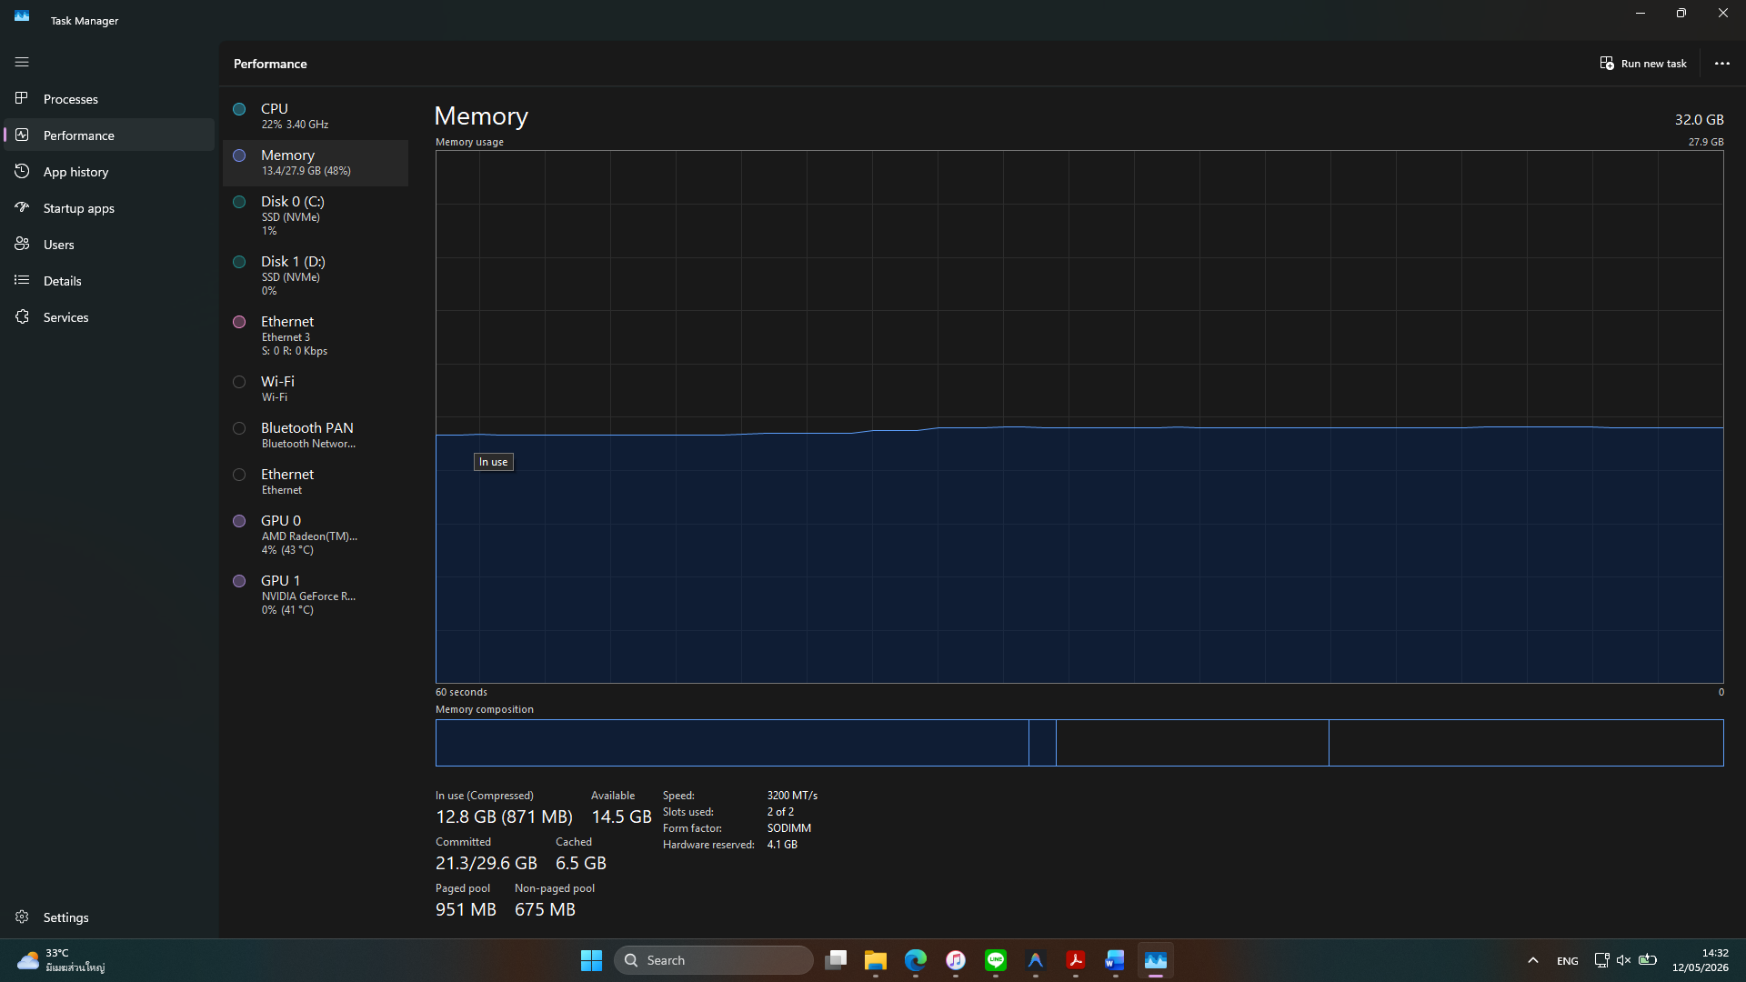
- PQ-TC-02: End-to-End Result Reconciliation (GxP Accuracy)
Objective:
To verify decision-making accuracy by reconciling automated results against a manual analysis. This test ensures the 5-minute sampling and 10-minute gap logic is applied consistently (ALCOA+ Accuracy).
Procedure:
- Manual Review: analyzes a "Complex Day" CSV manually, identifying all 25-minute violations and gap resets.
- System Analysis: Process the same file through AQR.
- Reconciliation: Match every timestamped interval in the report against the SME log.
Acceptance Criteria:
100% Correlation: All Start/End times, Min/Max values, and Status strings (Passed/Out of Spec) match perfectly.
Results:
Proven Reliability: Over 1 year of real deployment demonstrated 100% correlation between manual reviews and the AQR system analysis. All critical data points including timestamps, Min/Max values, and Pass/Fail statuses match perfectly."
- PQ-TC-03: Business Continuity (Restore & Standalone Reliability)
Objective:
Verify application portability across local drives.
Procedure:
- Move the root folder to drive `D:\`.
- Launch `app.exe` and process a test file.
Acceptance Criteria:
- Application launches and processes data without path-resolution errors.
- Audit trail correctly records the new path in its metadata header.
Results: Complied with the acceptance criteria.
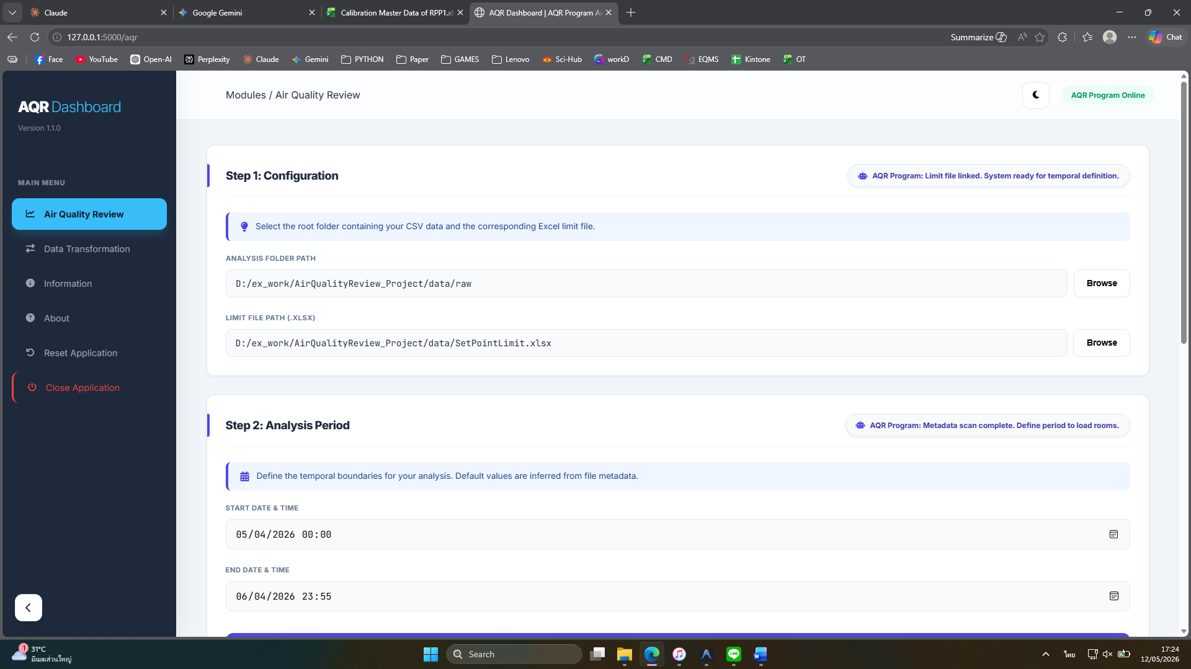
- PQ-TC-04: Production Data Transformation Lifecycle
Objective:
Verify end-to-end reliability of bulk-to-room CSV splitting.
Procedure:
- Split a set of bulk production files using the Transformation module.
- Verify 100% room extraction.
- Perform a bit-for-bit comparison of 3 random room files against the source.
Acceptance Criteria:
- No data loss or character corruption during splitting.
- Transformed CSVs include the mandatory "End of Report" footer.
- Evidence: Screenshot of the comparison between source bulk and extracted CSV data.
Results: Complied with the acceptance criteria.
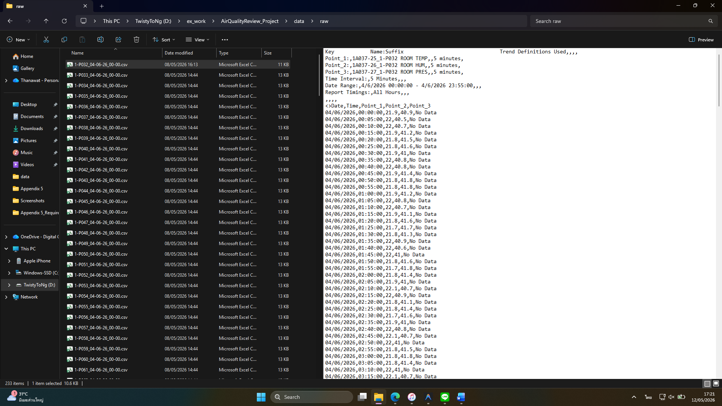
- PQ-TC-06: System Stability during Extended GUI Session
Objective:
Verify no significant memory leaks over an 8-hour shift.
Procedure:
- Keep AQR open for 8 hours, performing an analysis run every hour.
- Record memory usage after each run.
Acceptance Criteria:
- At the end of 8 hours, the "Idle Memory Usage" must be within 50MB of the initial "Idle Memory Usage" at Start.
- All 8 analysis runs must complete successfully.
Results: Complied with the acceptance criteria.
